Thursday Bidding Tips 13 Board 15 played on 9/8/2018 Cargill Pairs
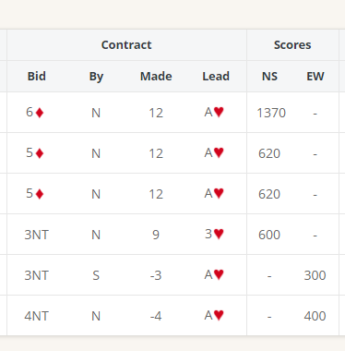
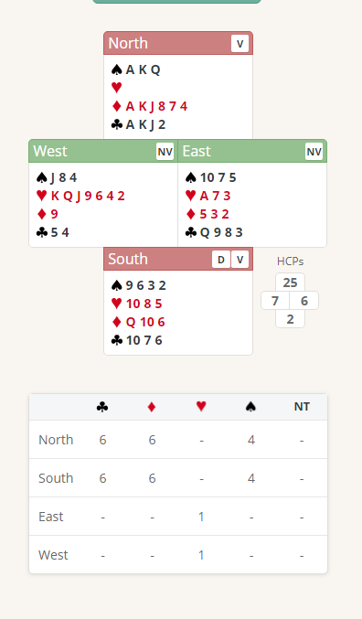

Suggested Bidding
N | E | S Dealer | W
 |  | Pass | 3H
Double | Pass | 3S | Pass
5D | Pass | Pass | Pass

- Wests Bid of 3 Hearts shows 6-10 Points 2 Honours in Hearts and 7 card suit
- Norths Takeout Double shows 12 plus points a like shortage in the did suit and at least 3 card cover in the other 3 suits
- Easts passes wit 6 points need to have 16= points or 3 quick tricks to support
- South is forced to bid and bids 3 spades a 4 card suit (their best suit)
- West passes
- North bids 5 Diamonds with 25 points (game points and actually have only 2 losing tricks (QD and QC) Also South at this level may pass 4 Diamonds
- All pass

Suggested Lead from East A Hearts (Top of partners call) North will trump

Further notes about
Takeout Double bidding http://www.nzbridge.co.nz/user/inline/2648/NZB%20Beginner%2008%20-%20Student%20Notes.pdf
Weak 2 and 3 openers
http://www.nzbridge.co.nz/user/inline/1754/NZB%20Beginner%2009%20-%20Student%20Notes.pdf

